**DIGITAL ELECTRONICS ( EC - 262)**

**ASSIGNMENT - 3**

**Question 1: What are Finite state Machines and its types**

**Answer 1 :** We know that synchronous sequential circuits change  affect  their states for every positive or negative transition of the clock signal based on the input. So, this behavior of synchronous sequential circuits can be represented in the graphical form and it is known as **state diagram**.

A synchronous sequential circuit is also called as **Finite State Machine** FSMFSM, if it has finite number of states. There are two types of FSMs.

* Mealy State Machine
* Moore State Machine

## Mealy State Machine

A Finite State Machine is said to be Mealy state machine, if outputs depend on both present inputs & present states. The **block diagram** of Mealy state machine is shown in the following figure.

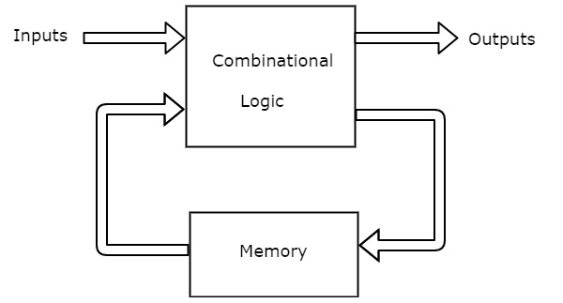

As shown in figure, there are two parts present in Mealy state machine. Those are combinational logic and memory. Memory is useful to provide some or part of previous outputs present states as input of combinational logic.

So, based on the present inputs and present states, the Mealy state machine produces outputs. Therefore, the outputs will be valid only at positive or negative transition of the clock signal.

The state diagram of Mealy state machine is shown in the following figure.

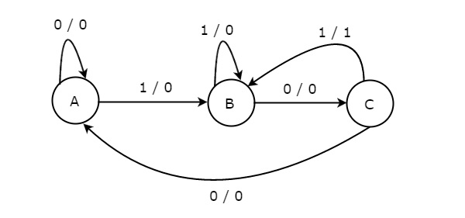

In the above figure, there are three states, namely A, B & C. These states are labelled inside the circles & each circle corresponds to one state. Transitions between these states are represented with directed lines. Here, 0 / 0, 1 / 0 & 1 / 1 denotes input / output. In the above figure, there are two transitions from each state based on the value of input, x.

In general, the number of states required in Mealy state machine is less than or equal to the number of states required in Moore state machine. There is an equivalent Moore state machine for each Mealy state machine.

**Moore State Machine**

A Finite State Machine is said to be Moore state machine, if outputs depend only on present states. The block diagram of Moore state machine is shown in the following figure.

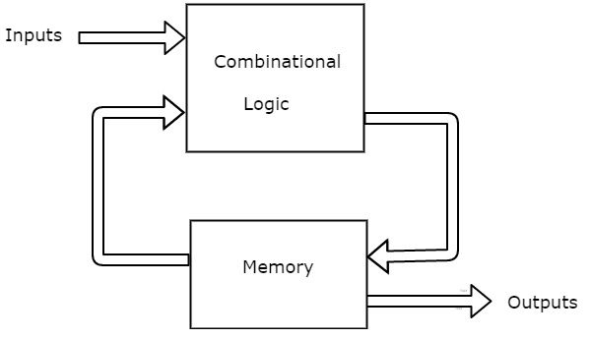

As shown in figure, there are two parts present in Moore state machine. Those are combinational logic and memory. In this case, the present inputs and present states determine the next states. So, based on next states, Moore state machine produces the outputs. Therefore, the outputs will be valid only after transition of the state.

The state diagram of Moore state machine is shown in the following figure.

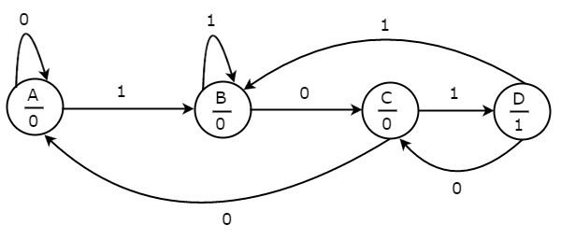

In the above figure, there are four states, namely A, B, C & D. These states and the respective outputs are labelled inside the circles. Here, only the input value is labeled on each transition. In the above figure, there are two transitions from each state based on the value of input, x.

In general, the number of states required in Moore state machine is more than or equal to the number of states required in Mealy state machine. There is an equivalent Mealy state machine for each Moore state machine. So, based on the requirement we can use one of them.

**Question 3: Make the state diagram of 1010 sequence detector using Mealy and Moore machine.**

**Answer 3 :** Every digital system can be partitioned into two parts. Those are data path digital circuits and control circuits. Data path circuits perform the functions such as storing of binary information data and transfer of data from one system to the other system. Whereas, control circuits determine the flow of operations of digital circuits.

It is difficult to describe the behavior of large state machines using state diagrams. To overcome this difficulty, Algorithmic State Machine ASM charts can be used. ASM charts are similar to flow charts. They are used to represent the flow of tasks to be performed by data path circuits and control circuits.

Basic Components of ASM charts

Following are the three basic components of ASM charts.

* State box
* Decision box
* Conditional output box

**State box**

State box is represented in rectangular shape. Each state box represents one state of the sequential circuit. The symbol of state box is shown in the following figure.

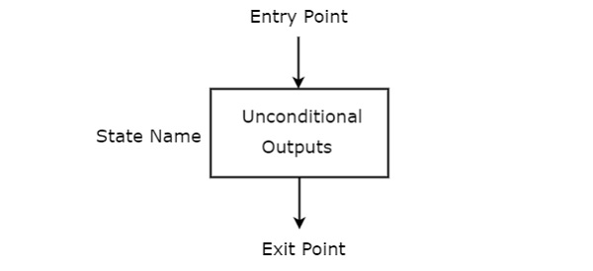

It is having one entry point and one exit point. Name of the state is placed to the left of state box. The unconditional outputs corresponding to that state can be placed inside state box. Moore state machine outputs can also be placed inside state box.

**Decision box**

Decision box is represented in diamond shape. The symbol of decision box is shown in the following figure.

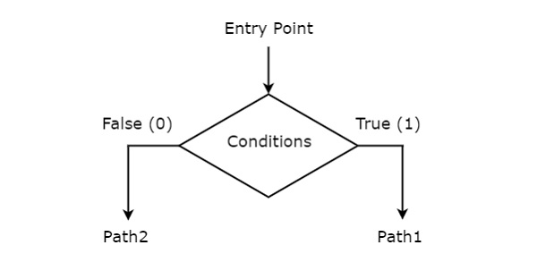

It is having one entry point and two exit paths. The inputs or Boolean expressions can be placed inside the decision box, which are to be checked whether they are true or false. If the condition is true, then it will prefer path1. Otherwise, it will prefer path2.

Conditional output box

Conditional output box is represented in oval shape. The symbol of conditional output box is shown in the following figure.

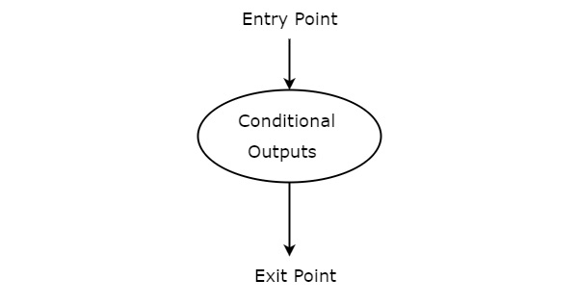

It is also having one entry point and one exit point similar to state box. The conditional outputs can be placed inside state box. In general, Mealy state machine outputs are represented inside conditional output box. So, based on the requirement, we can use the above components properly for drawing ASM charts.